Title: | Door Control Module  SW Component WindowApp

History
Issue status  (Index) | Maturity/Date  (draft/invalid/valid)  (dd-mmm-yyyy) | Author  Department | Check/Release  Department | Description
1.0 | Draft  04-09-21 | Vicente Guerrero | Vicente Guerrero | Creation of the document

Table of Contents
1 Purpose 3
2 Definitions and abbreviations 3
3 Realization constraints and targets 3
4 SW Conceptual design 4
5 SW Component internal breakdown 4
5.1 Functional Decomposition 4
5.2 Function void WindowHandler_Init ( ) 6
5.3 Function void WindowHandler_Run( ) 6
5.4 Function int ReportIdleOperation(char* frame, int currentActuation) 6
5.5 Function int HandleWindowPositionForActuation (int winPos) 7
5.6 Function int ReportWindowDown (char *frame) 8
5.7 Function int HandleManualWindowActuation (char *frame, int button, int buttonState) 9
5.8 Function int ReportManualWindowRequest(char *frame, int button, int buttonState, int door) 10
5.9 Function int HandleConfortCmdWindowActuation (char *frame, int door, int button, int buttonState) 12
5.10 Function int HandleDCUWindowActuation (char *frame, int door, int windowPos) 14
5.11 Function int ReportLockInWindowPos (char *frame, int door) 15
5.12 Function int ManageWindowError (uint isWindowError, int powerMode) 17
5.13 Function int ManageButtonError (uint isButtonStuck, int powerMode) 17

Purpose
This document describes the design for the SW Component “WindowApp” from the Door Control Module Project, contained in the Software Architecture DCU.

Definitions and abbreviations
Definitions
SW Unit | The smallest unit of software that can be compiled and built.
SW Component | A piece of software and an element of the SW Architecture that implement the logic and algorithms of the software system.
Function | A set of logical instructions inside a SW Component that has input parameters and output parameters. It satisfies SW Requirements
Requirement | Condition to be accomplished that it is needed for the customers or stakeholders for the final product

Abbreviations
DCU – Door Control Module
SW - Software
App – Application
SDD- Software Detailed Design
SWA – Software Architecture
References
N° | Document name | Reference
1 | SW Architecture description | SWA_DCU
2 | SW Requirements | Traceability Matrix Template

Realization constraints and targets
With this software detail design it is expected that the developer can implement and build all the functions from the component in order to be tested and functional.

SW Conceptual design
The Software component to be designed is WindowApp from the SWA_DCU. This component is located in the application layer of the Software and it will implement the main logic for the Window Control Application. Some characteristics are:
- Determine conditions for Remote and Manual Operation for Window Control
- Determine and report Window Position status to CAN Bus

SW Component internal breakdown
The next diagram shows the internal breakdown of the SW Component in SW Units. There will be just one SW Unit with one .c Source file and one .h Header file.

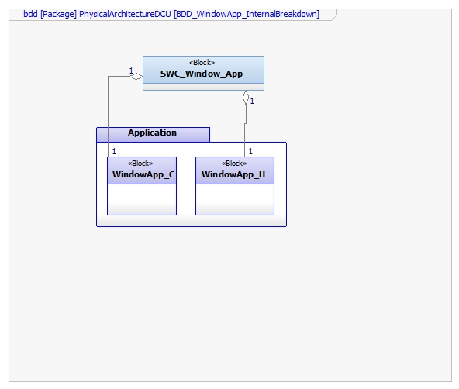

Functional Decomposition
The next diagram shows the functional decomposition of the operations performed by the SW Component WindowApp. Basically, the main function is WindowHandler_Run, which calls and controls the other functions, data flow and interfaces from other components according to the SW Architecture.

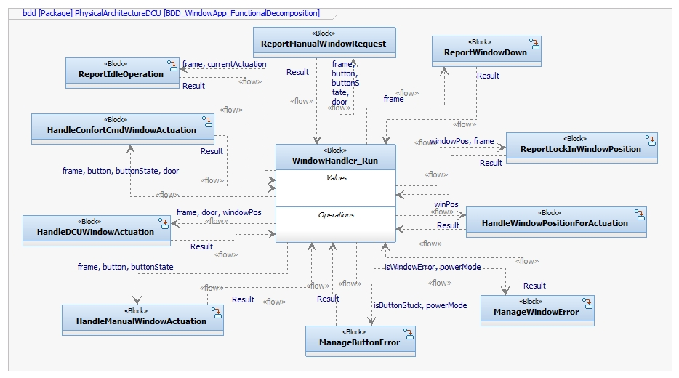
Function Description and Dynamic Behavior

Function void WindowHandler_Init ( )

Description | Initialization of the Software Component WindowApp
Return Value | none
Precondition | Function can only be called when system has initialized or reset
Post condition | Function WindowHandler_Run shall start after the execution of WindowHandler_Init()
Error Conditions
Requirements

Function void WindowHandler_Run( )
Description | Function that will perform the periodic operations and calls the rest of the functions in the Component except for the WindowHandler_Init.
Return Value | None
Precondition | Function can only be called after the initialization of the SW Component.
Post condition | After the execution of this function, WindowApp component can start to execute its functions.
Error Conditions
Requirements

Function int ReportIdleOperation(char* frame, int currentActuation)
Description | This function validates if there is an actuation and if not, reports idle operation
Parameter 1  frame | Pointer to the DCU frame
Parameter 2  currentActuation | Indicates the current window Actuation  0 – NO_ACTUATION  1 – OPEN_WINDOW_ACTUATION  2 – CLOSE_WINDOW_ACTUATION
Return Value | Operation result  0 – FUNCTION_OK  -1 – FUNCTION_ERROR
Precondition | DCU Frames have to be requested
Post condition | The function Will report DCU_X.WindowOp as WINDOW_IDLE.
Error Conditions | If another value for currentActuation is input, then function shall return FUNCTION_ERROR.
Requirements | DCU_SWR_32, DCU_SWR_33, DCU_SWR_34, DCU_SWR_35

Dynamic Behavior
State Chart

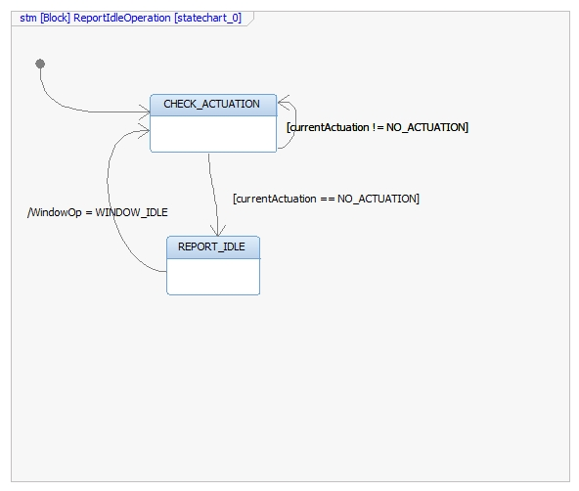

Function int HandleWindowPositionForActuation (int winPos)
Description | This function monitors the state of window position and performs Open Actuation depending of the conditions.
Parameter 2  winPos | Indicates the Window Position  0 – COMPLETELY_OPEN  1 – IN_BETWEEN  2 – COMPLETELY_CLOSE  3 – ERROR
Return Value | Operation result  0 – FUNCTION_OK  -1 – FUNCTION_ERROR
Precondition | Window position has to be requested before in order to call this function.
Post condition
Error Conditions | If a different value from winPos is input, then function shall return FUNCTION_ERROR
Requirements | DCU_SWR_36

Dynamic Behavior
State Chart
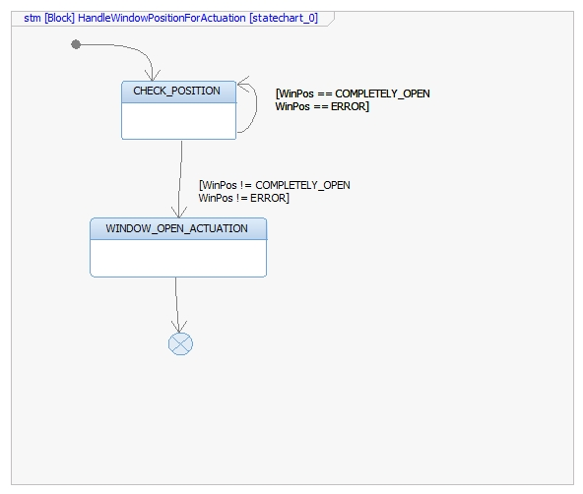

Function int ReportWindowDown (char *frame)
Description | This function only reports the DCU_1.WindowOp as WINDOW_DOWN
Parameter 1 Input  *frame | Pointer to the DCU frame
Return Value | Operation result  0 – FUNCTION_OK  -1 – FUNCTION_ERROR
Precondition | DCU_1 frame has to be requested before in order to call this function.
Post condition | DCU_1 frame is resent with the new value in DCU_1.WindowOp
Error Conditions | If a different frame than DCU_1 is input, then function shall return FUNCTION_ERROR
Requirements | DCU_SWR_39
Dynamic Behavior
Function only sends a request without any conditions. There is only one state for this function.

Function int HandleManualWindowActuation (char *frame, int button, int buttonState)
Description | This function handles the manual Window Control Actuation when buttons are pressed and the type of pressure for each one. It also validates the DCU Frames in order to perform the Window Actuation.
Parameter 1 Input  *frame | Pointer to the DCU frame to analyze
Parameter 2 Input  button | Indicates the selected button  - OPEN_BTN  - CLOSE_BTN
Parameter 3 Input  buttonState | Indicates the status of the pressed button  0 – BTN_NOT_PRESSED  1 – SHORT_BTN_PRESS  2 – LONG_BTN_PRESS
Return Value | Operation result  0 – FUNCTION_OK  -1 – FUNCTION_ERROR
Precondition | Button status and DCU frames have to be requested before in order to call this function.
Post condition | .
Error Conditions
Requirements | DCU_SWR_76, DCU_SWR_77, DCU_SWR_78

Dynamic Behavior
State Chart
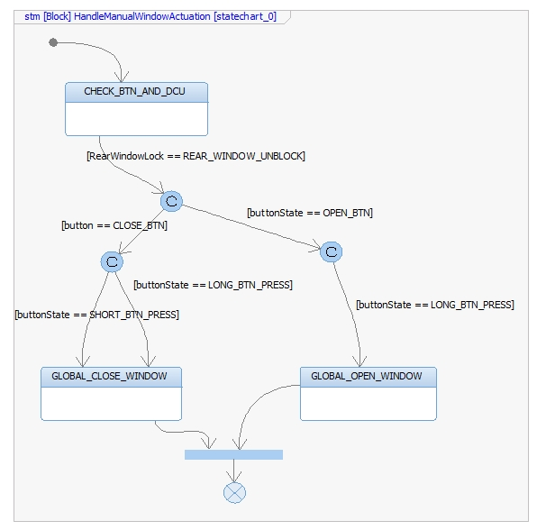

Function int ReportManualWindowRequest(char *frame, int button, int buttonState, int door)
Description | This function handles the manual mode when buttons for Window Control Actuation are pressed and the type of pressure for each one. It also validates the DCU Frames in order to perform the Window Actuation.
Parameter 1 Input  *frame | Pointer to the DCU frame to analyze
Parameter 2 Input  button | Indicates the selected button  0 OPEN_BTN  1 CLOSE_BTN
Parameter 3 Input  buttonState | Indicates the status of the pressed button  0 – BTN_NOT_PRESSED  1 – SHORT_BTN_PRESS  2 – LONG_BTN_PRESS
Parameter 4 Input | Indicates the selected Door for Actuation  0 – DRIVER_DOOR  1 – PASSENGER_DOOR  2 – REAR_LEFT_DOOR  3 – REAR_RIGHT_DOOR
Return Value | Operation result  0 – FUNCTION_OK  -1 – FUNCTION_ERROR
Precondition | Button status and DCU frames have to be requested before in order to call this function.
Post condition | Depending on the frame and selected door, the DCU Frame has to be reported
Error Conditions | If another value for DoorSelected or ButtonPressed is input, then function shall return FUNCTION_ERROR
Requirements | DCU_SWR_79, DCU_SWR_80, DCU_SWR_81, DCU_SWR_82, DCU_SWR_83, DCU_SWR_84, DCU_SWR_85, DCU_SWR_86

Dynamic Behavior
State Chart
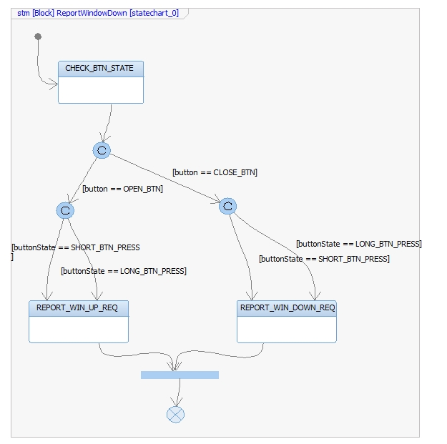

Function int HandleConfortCmdWindowActuation (char *frame, int door, int button, int buttonState)
Description | This function monitors the transitions and states of the ConfortCmd byte from the BCM_2 frame and performs an the window actuation.
Parameter 1 Input  *frame | Pointer to the BCM_2 frame
Parameter 2 Input  DoorSelected | Indicates the selected door  0 – DRIVER_DOOR  1 – PASSENGER_DOOR  2 – REAR_LEFT_DOOR  3 – REAR_RIGHT_DOOR
Parameter 3 Input  button | Indicates the selected button  0 OPEN_BTN  1 CLOSE_BTN
Parameter 4 Input  buttonState | Indicates the status of the pressed button  0 – BTN_NOT_PRESSED  1 – SHORT_BTN_PRESS  2 – LONG_BTN_PRESS
Return Value | Operation result  0 – FUNCTION_OK  -1 – FUNCTION_ERROR
Precondition | BCM_2 frame has to be requested before in order to call this function.
Post condition
Error Conditions | If a different frame than BCM_2 is input, then function shall return FUNCTION_ERROR
Requirements | DCU_SWR_88, DCU_SWR_89, DCU_SWR_90, DCU_SWR_91

Dynamic Behavior
State Chart
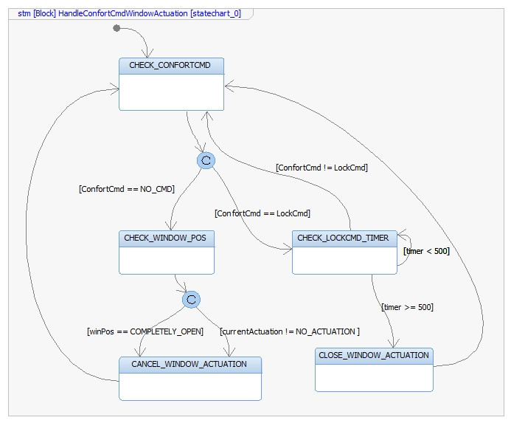

Function int HandleDCUWindowActuation (char *frame, int door, int windowPos)
Description | This function handles the remote operation from the DCU_1 frame in order to perform the Window Actuation.
Parameter 1 Input  *frame | Pointer to the DCU_1 frame
Parameter 2 Input  door | Indicates the selected door  0 – DRIVER_DOOR  1 – PASSENGER_DOOR  2 – REAR_LEFT_DOOR  3 – REAR_RIGHT_DOOR
Parameter 4 Input  buttonState | Indicates the status of the pressed button  0 – BTN_NOT_PRESSED  1 – SHORT_BTN_PRESS  2 – LONG_BTN_PRESS
Return Value | Operation result  0 – FUNCTION_OK  -1 – FUNCTION_ERROR
Precondition | DCUs frames has to be requested before in order to call this function.
Post condition
Error Conditions | If a different frame than DCU_1 is input, then function shall return FUNCTION_ERROR
Requirements | DCU_SWR_93, DCU_SWR_94, DCU_SWR_95, DCU_SWR_96, DCU_SWR_98, DCU_SWR_99, DCU_SWR_100, DCU_SWR_101, DCU_SWR_103, DCU_SWR_104, DCU_SWR_105, DCU_SWR_106

Dynamic Behavior
State Chart
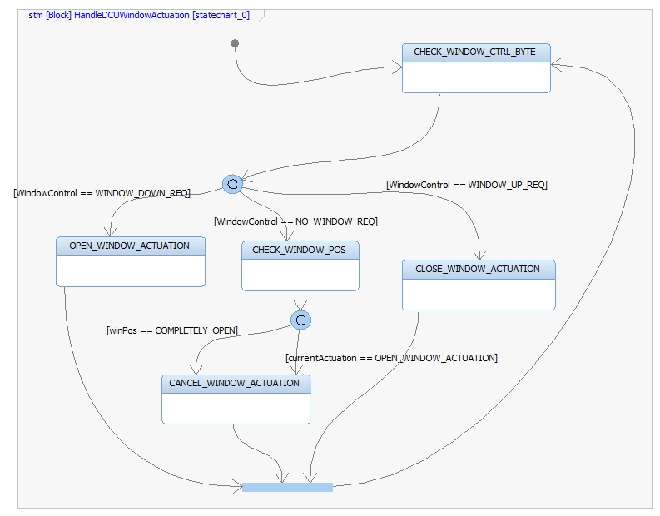

Function int ReportLockInWindowPos (char *frame, int door)
Description | This function reports the determined Lock Status for an specific Door in the WindowPos byte of DCU frame
Parameter 1 Input  *frame | Pointer to the first DCU frame to analyze
Parameter 2 Input  door | Indicates the selected door  0 – DRIVER_DOOR  1 – PASSENGER_DOOR  2 – REAR_LEFT_DOOR  3 – REAR_RIGHT_DOOR
Return Value | Operation result  0 – FUNCTION_OK  -1 – FUNCTION_ERROR
Precondition | All DCU frames have to be requested before in order to call this function.
Post condition | Driver door shall transmit its DCU frame with the LOCK_REQ value on the LockingReq byte.
Error Conditions | If a different frame than DCU_1 to DCU_4 is input, then function shall return FUNCTION_ERROR.  If another value for door is input, function shall return FUNCTION_ERROR.
Requirements | DCU_SWR_116, DCU_SWR_117, DCU_SWR_118, DCU_SWR_119
Dynamic Behavior
State Chart
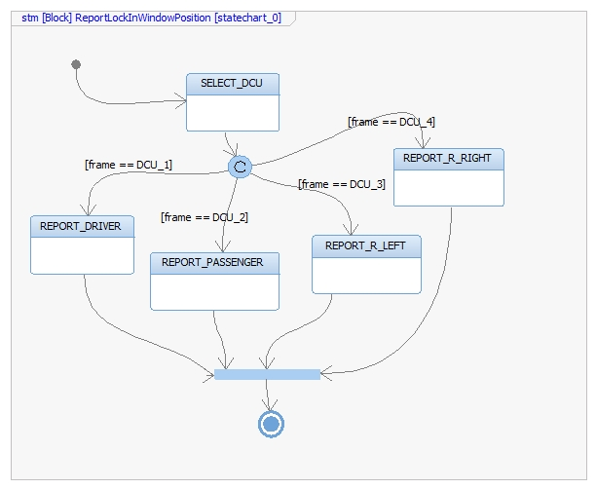

Function int ManageWindowError (uint isWindowError, int powerMode)
Description | This function manages the Window errors
Parameter 1 Input  isWindowError | Value that indicates if a Window Error has occured  0 – FALSE  1 – TRUE  Any other value greater than 1 shall be considered as TRUE.
Parameter 6 Input  powerMode | Indicates the current System Power Mode  0 – OFF  1 – RUN
Return Value | Operation result  0 – FUNCTION_OK  -1 – FUNCTION_ERROR
Precondition | Window Position has to be requested.  System Power Mode have to be requested.
Post condition
Error Conditions | If another value for powerMode is input, function shall return FUNCTION_ERROR.
Requirements | DCU_SWR_149

Dynamic Behavior
State Chart
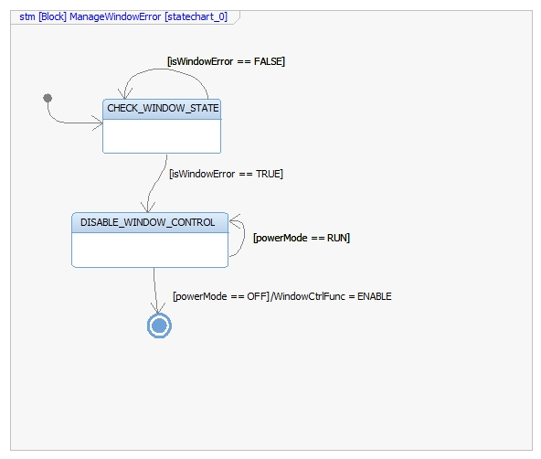

Function int ManageButtonError (uint isButtonStuck, int powerMode)
Description | This function manages the Button Stuck
Parameter 1 Input  isButtonStuck | Value that indicates if a Button Stuck has occured  0 – FALSE  1 – TRUE  Any other value greater than 1 shall be considered as TRUE.
Parameter 6 Input  powerMode | Indicates the current System Power Mode  0 – OFF  1 – RUN
Return Value | Operation result  0 – FUNCTION_OK  -1 – FUNCTION_ERROR
Precondition | Button Status has to be requested.  System Power Mode have to be requested.
Post condition
Error Conditions | If another value for powerMode is input, function shall return FUNCTION_ERROR.
Requirements | DCU_SWR_148

Dynamic Behavior
State Chart

